

Mohd. Razia Alangir Banu
D. VENKAT SAI
2520090034
CSIT
CO-4

Case Study: Meesho – Smart Delivery Route Optimization & Logistics Management System
Meesho handles deliveries across thousands of locations daily and requires efficient route planning to reduce delivery time and transportation costs. In this system, the delivery network is represented as a weighted graph where warehouses, hubs, and customer locations are nodes, while roads and transportation routes are edges. Dijkstra's Algorithm is used to find the shortest path in graphs with positive edge weights. Bellman-Ford
Algorithm is implemented to handle networks containing negative-weight routes such as discounts or cost adjustments. Floyd-Warshall Algorithm is used to compute shortest paths between all pairs of locations. These algorithms help optimize logistics operations, reduce delivery costs, and improve delivery efficiency.

Implementation Details
- The delivery network is modeled as a weighted graph containing warehouses and customer locations.
- Dijkstra’s Algorithm is used to find the shortest delivery path for positive-weight routes.
- Bellman-Ford Algorithm is implemented to handle graphs with negative edge weights.
- Floyd-Warshall Algorithm is used for all-pairs shortest path computation.
- Route distances and transportation costs are analyzed using graph traversal techniques.
- The system improves delivery efficiency and minimizes transportation costs through optimized route selection.
Output:

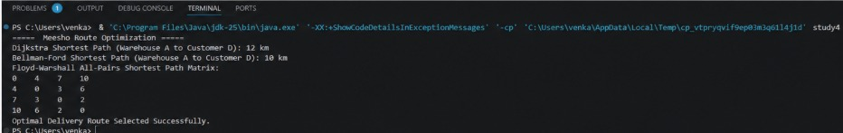

The Meesho logistics management system effectively utilizes Dijkstra’s, Bellman-Ford, and Floyd-Warshall algorithms for route optimization. These algorithms help identify the shortest delivery paths, reduce transportation costs, and improve overall delivery efficiency in large-scale logistics networks.

Github link: https://github.com/Venkat-267-byte/DSA-II

